Project title | Circular economy in the valorization of tailings - sustainable solutions for the just transition in the Jiu Valley, Romania
Sector | Circular economy
Location | South-West Romania (cities of Jiu Valley, Hunedoara)
Project purpose | The implementation of sustainable circular economy solutions for the valorization of tailings, contributing to the just transition in the Jiu Valley by regenerating the environment and creating new economic and social opportunities.
Beneficiaries of the project | The beneficiaries of this project include the local communities of Jiu Valley, companies in the energy and agricultural sectors, public authorities, as well as environmental organizations, all benefiting from ecological regeneration, job creation and the development of new sources of energy and food.
Project relevance and need | The relevance of the project in the Jiu Valley is particularly high, given the urgent need to revitalize a region affected by the decline of the mining industry and to support the transition to renewable energy sources and sustainable agriculture, as it can support the financial development of the region, through crops biomass in obtaining energy and food.  This project can represent a significant boost for local and regional businesses in the Jiu Valley, which will be able to capitalize on the resources regenerated through the circular economy of waste dumps. This will allow them to more efficiently distribute their products to other regions of Romania and expand their exports to international markets, including neighboring countries, in an energy and cost efficient way.
Implementing actor | The study and works for energy recovery and a sustainable agriculture through the circular economy of tailings could take place under the coordination of ITI Valea Jiului, in cooperation with ADR Vest and the Ministries of Environment, Energy and Agriculture, to support the sustainable development of the region and its integration in Romania's green economy.
Activities | Preparation of a study examining the current status of tailings dumps for the implementation of biomass crops for energy and food  Research and development in technologies for the recovery of mining waste into usable resources such as food, biofuels, renewable energy or building materials.  Vocational training and retraining programs for the residents of Jiu Valley, focusing on preparing them for the new jobs created in the sectors of sustainable agriculture, renewable energy and waste management.
Expected result(s) | This project will contribute to the improvement of soil quality and biodiversity in the Jiu Valley area, supporting the sustainable development of the region and its integration into Romania's green economy.  Thus, new jobs will be generated in agriculture, renewable energy and waste management, contributing to local economic growth and supporting communities affected by industrial decline. This project, in addition to increasing connectivity, will lead to the implementation of circular economy solutions that minimize the impact of waste through recycling and resource recovery, thus contributing to the reduction of greenhouse gas emissions and the promotion of a more sustainable economy.
Expected contribution(s) and impact(s) | Estimated energy savings: 400,000 MWh/year  Estimated production of renewable energy: 100,000 MWh/year  Estimated GHG emission savings: 70,000 tCO₂ equivalent/year  These estimates are indicative and may vary depending on the type of biomass grown, the efficiency of the technologies used and the degree of community involvement in the implementation of the project.
Institutional framework | This project largely depends on the cooperation with the Ministries of Environment, Energy and Agriculture, with the support of ADR Vest and ITI Valea Jiului.
Budget | The total budget for the implementation of biomass crops to generate renewable energy and food products of the 100 hectares of waste dumps required for this project: EUR 2,500,000.
Sources of funding or financing | The Just Transition Fund, the Romanian Government, the Horizon Europe Programme, the InvestEU Programme
Implementation schedule | Short and medium term duration; could be completed in the next five years.
Sustainability | The project will provide revenue to energy companies and will also be a driver of economic development in the entire area, while providing a reduction in waste and carbon emissions in the region.
Replication | Given that the utilization of waste dumps as resources within a circular economy is quite underdeveloped in Romania, there is a great potential to replicate the action in other regions.

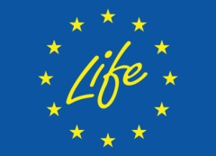
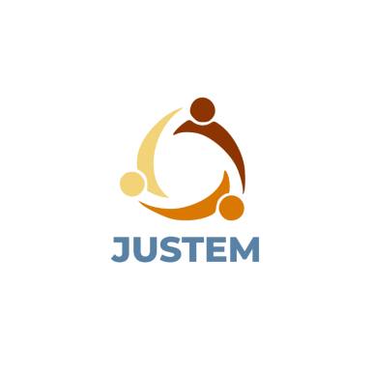
September, 2024
Date of release
Emilia-Cornelia Dunca, AISVJ
Sabina Irimie, AISVJ
Authors
ABOUT
Co-funded by the European Union. Views and opinions expressed are however those of the author(s) only and do not necessarily reflect those of the European Union or CINEA. Neither the European Union nor the granting authority can be held responsible for them.

